iTwin Technology
Saniya Mehnaz, Rayeesa Tasneem
B.Tech III yr Department of Computer Science & Engineering
Sree Visvesvaraya Institute of Technology & Science, Mahabubnagar, Telangana, India.

Abstract: iTwin is an endless secure USB device that enables users to access, edit and share all their files and media between any two online computers anywhere in the world. The only limit is the size of computer’s hard drive.iTwin is an excellent solution that allows bi-directional file access without the security and privacy risks of the cloud and USB flash drives. iTwin uses well evaluated crypto protocols and algorithms. It has features like no temp files, remote disable, password support and twin trust authentication.

Keywords: iTwin, USB, cloud storage, crypto protocols.

1. INTRODUCTION

iTwin is like two ends of an rod, without rod.It is simple to use as a flash drive. It is exactly like plug and play. iTwin enables you to have access to your desktop’s files while you are travelling. Similarly, you can also use iTwin to access your office desktop’s files while on the go. The only drawback is the speed of your internet connection. The faster it is better is your experience. You can edit files on your desktop remotely when you have access to the desktop. You can also backup files to your desktop or office desktop.

2. iTWIN USAGE

When you plug-in iTwin, you will see a pop-up window, just as you would if you connect USB device. Drag and drop files into this window to share as many as you want. Leave one of the iTwin connected to the computer. Plug-in the other halves of the iTwin to the computer, to which you want to view, edit or remove those files. Eventhough, if you remotely edit or remove files on the second computer, files on the first computer will not be lost This is the another advantage of iTwin Be sure that the two computers are online.
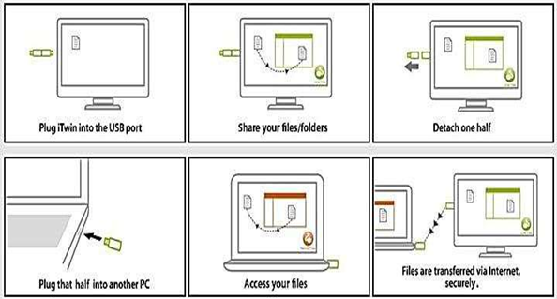
Figure.1

3. FEATURES OF ITWIN

- iTwin is like a limitless secure USB flash drive.

- You can remotely edit shared files on your computer without replacing files on main computer.

- Back-up data is safe and secure and it is very easy.

- There are no subscription fees for file access. But you need to pay for one-time for drop box account with unlimited storage, which is included in device cost. So, no additional fees ever.

- iTwin doesn’t store any data, it just enables a secure connection between two computers. You can access files on remote computer, only when you have physical half of the iTwin with you. Additionally, you can setup password for your iTwin for more security. It has also a feature to remotely disable connection to computer with other half of iTwin.It even uses AES encryption in order to transfer data securely.

- Two iTwins together randomly generate a 256-bit AES key, every time when they are paired physically and plugged into a computer. Smart crypto key resides on both halves of paired iTwin. Smart crypto key is used for encrypting data congestion between two iTwins.

- Unplug iTwin and all temp files are cleared automatically. This is very much useful when using a computer that doesn’t belong to you.

- iTwin supports passwords of any length. Unlike other web and cloud services, iTwin password is stored on itself, not on any server.If you forget your password, simply pair both halves of your iTwin and plug them into a computer and set a new password. There is no need for any technical support.

- When using iTwin, connection between any two computers is symmetrical. Access, copy, backup and remotely edit files on 1st computer from 2nd computer, and on 2nd computer from 1st computer. You will have access to files on both computers.

- In short, iTwin is just like a wireless device connecting two systems online and securely transferring data between them.

4. AES ENCRYPTION

AES(Advanced Encryption Standard) is a identification for the encryption of electronic data established by the U.S National Institute Of Standards And Technology(NIST) in 2001.

AES has been adopted by U.S government and it replaces the Data Encryption Standard(DES), which was published in 1977.The algorithm reported by AES is a symmetric-key algorithm, meaning the same key is used for encrypting and decrypting the data.

- Description of the Cryptograph:

- AES is based on a design principle known as a substitution-permutation network, combination of both substitution and permutation, and is quick in both software and hardware.

- AES is a variant of encryption family which has fixed block size of 128,192, or 256-bits.

- AES operates on a 4*4 matrix of bytes, termed as ‘state’.

- Key size used for an AES cryptograph specifies the number of repetitions of transformation rounds that are required to convert input in plain text into output in cryptograph text.

- 10 cycles of repetitions for 128-bit keys, 12 cycles of repetitions for 192-bit keys, 14 cycles of repetition for 256-bit keys.

- Security:
- The design and strength of all key lengths of the AES algorithm(i.e, 128,192 and 256) are sufficient to protect categorized information up to the confidential level.
- Highly confidential information requires use of either the 192 or 256 key lengths.
- The implementation of AES in commodity deliberates to safeguard national security systems and/or information must be evaluated and certified by NSA prior to their accession and use.
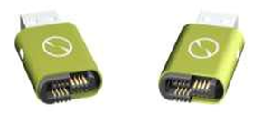
c. Performance:
- High speed and low RAM requirements were benchmark of the AES election process. Thus AES executes well on a wide variety of hardware, from 8-bit smart cards to high performance computers.

5. COMPARISON OF ITWIN WITH USB AND CLOUD STORAGE
- A USB flash drive is a data storage device that consists of flash memory with an amalgamated universal serial bus interface.
- A Cloud storage is a model of data storage where digital data is stored in logical pools, the physical storage spans multiple servers and physical environment is typically owned and managed by a hosting company and is accessed whenever needed.
- Drawback of USB is its size because of which it can be misplaced easily.This is a problem if the data it contains is important and secret.
- In Cloud storages, the data can be stolen or misused if the account is hacked by someone.There are many more more drawbacks like limited storage, no security, backup, temp files, no remote disable.

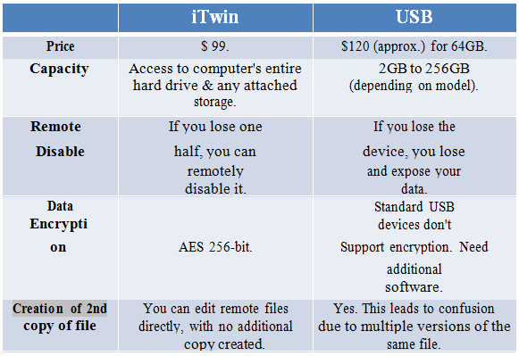
Figure.2

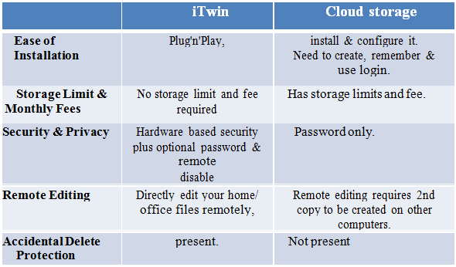
Figure.3

6. TECHNICAL SPECIFICATIONS
A. Software requirements:
- Requires minimum of 512 MB RAM, but 1GB RAM is recommended.
- Requires 15 MB hard disk space.
- USB 2.0 port.
- Compatible with windows/OS X.
- Requires broadband internet access.
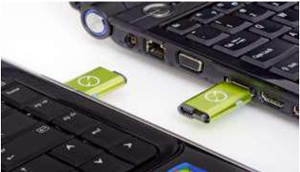

7. CONCLUSION
iTwin is a extra-ordinary solution for users who wish to work from home. They can remotely access, edit, and share files between home and office computers. iTwin bypasses cloud services to turn your physical storage into its own networking solution. Moreover, iTwin is simple plug and play type device which solves drop box limitations extensively.

REFERENCES
- "USB ‘A’ Plug Form Factor Revision 1.0" (PDF). USB Implementers Forum. 23 March 2005. p. 1. Retrieved 4 April
2012.
- USB deserves more support, "Business", Boston Globe Online (Simson), 1995-12-31, retrieved 2011-12-12
- USB connector guide". C2G. Retrieved 2 December 2013.

